Day9_DataProviders And Listeners

TASK- 01

package Test_Day6;

import org.testng.annotations.Test;

import org.testng.annotations.DataProvider;

public class CE_1 {

@Test(dataProvider = "dp", priority = 1)

public void addition(Integer n1, Integer n2) {

System.out.println("Add : " + n1 + "+" + n2 + "->" + (n1+n2));

}

@Test(dataProvider = "dp", priority = 2)

public void subraction(Integer n1, Integer n2) {

System.out.println("Sub : " + n1 + "-" + n2 + "->" + (n1-n2));

}

@Test(dataProvider = "dp", priority = 4)

public void multiplication(Integer n1, Integer n2) {

System.out.println("Mul : " + n1 + "*" + n2 + "->" + (n1*n2));

}

@Test(dataProvider = "dp", priority = 3)

public void division(Integer n1, Integer n2) {

System.out.println("Div : " + n1 + "/" + n2 + "->" +(n1/n2));

}

@DataProvider

public Object[][] dp() {

return new Object[][] {

new Object[] { 20, 18 },

new Object[] { -100, -20 },

};

}

}

OUTPUT:

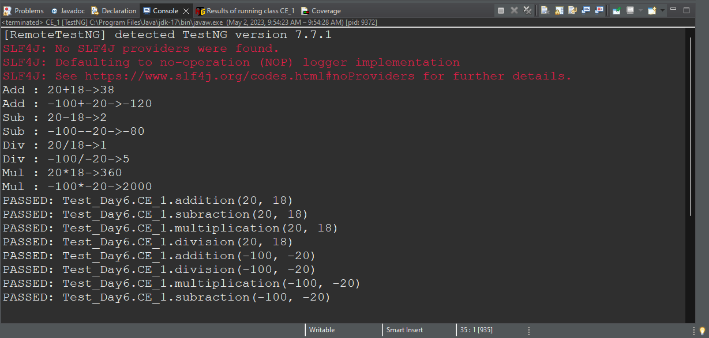

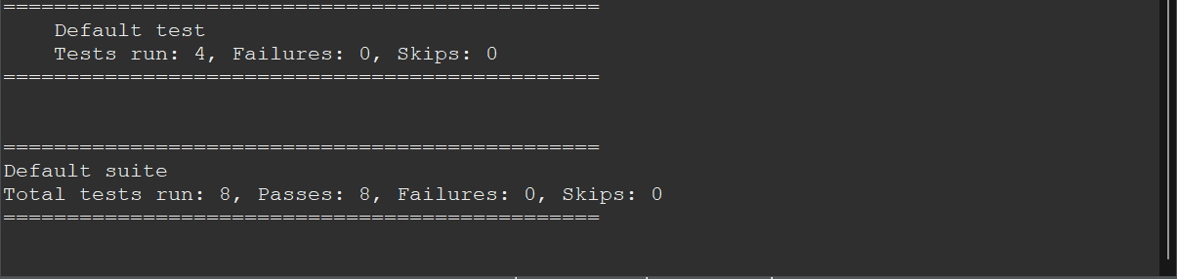

TASK- 02 & 03

package Test_Day6;

import org.testng.annotations.Test;

import io.github.bonigarcia.wdm.WebDriverManager;

import org.testng.annotations.BeforeMethod;

import java.util.concurrent.TimeUnit;

import org.openqa.selenium.By;

import org.openqa.selenium.WebDriver;

import org.openqa.selenium.WebElement;

import org.openqa.selenium.chrome.ChromeOptions;

import org.openqa.selenium.edge.EdgeDriver;

import org.testng.Assert;

import org.testng.annotations.AfterMethod;

public class CE_2 {

WebDriver driver;

@Test

public void testcase_01() {

driver.get("https://demo.wpeverest.com/user-registration/guest-registration-form/");

driver.manage().window().maximize();

String expectedTitle = "Guest Registration Form – User Registration";

String currentTitle = driver.getTitle();

System.out.println(currentTitle);

Assert.assertEquals(expectedTitle, currentTitle);

}

@Test

public void testcase_02() throws InterruptedException {

driver.get("https://www.godaddy.com/");

driver.manage().window().maximize();

driver.manage().timeouts().implicitlyWait(60, TimeUnit.MINUTES);

driver.findElement(

By.xpath("//*[@id=\"id-631b049a-e9c0-4d24-8710-c504745206dd\"]/div[2]/div[1]/ul/li[1]/button")).click();

Thread.sleep(5000);

driver.findElement(By.xpath(

"//*[@id=\"id-631b049a-e9c0-4d24-8710-c504745206dd\"]/div[2]/div[1]/ul/li[1]/div/div[2]/div[1]/ul/li[2]/a"))

.click();

Thread.sleep(5000);

}

@Test

public void testcase_03() throws InterruptedException {

driver.get("https://www.godaddy.com/");

driver.manage().window().maximize();

driver.manage().timeouts().implicitlyWait(20, TimeUnit.SECONDS);

Thread.sleep(5000);

driver.findElement(

By.xpath("//*[@id=\"id-631b049a-e9c0-4d24-8710-c504745206dd\"]/div[2]/div[1]/ul/li[1]/button")).click();

Thread.sleep(5000);

driver.findElement(By.xpath(

"//*[@id=\"id-631b049a-e9c0-4d24-8710-c504745206dd\"]/div[2]/div[1]/ul/li[1]/div/div[2]/div[1]/ul/li[2]/a"))

.click();

Thread.sleep(5000);

String actualTitle = driver.getTitle();

System.out.println(actualTitle);

Thread.sleep(5000);

boolean isSearchBoxPresent = driver.findElement(By.name("searchText")).isDisplayed();

Assert.assertEquals(isSearchBoxPresent, true);

}

@BeforeMethod

public void beforeMethod() {

ChromeOptions co = new ChromeOptions();

WebDriverManager.chromedriver().setup();

driver = new EdgeDriver();

}

@AfterMethod

public void afterMethod() {

driver.quit();

}

}

OUTPUT:

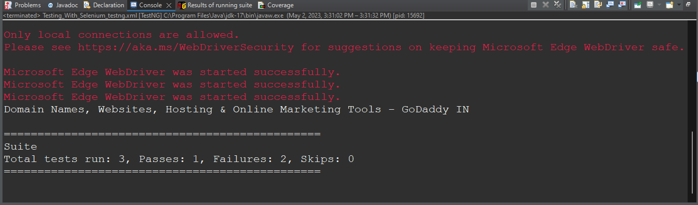

TASK- 04

package Test_Day6;

import org.testng.annotations.Test;

import io.github.bonigarcia.wdm.WebDriverManager;

import org.testng.annotations.BeforeMethod;

import org.testng.annotations.Parameters;

import org.openqa.selenium.By;

import org.openqa.selenium.WebDriver;

import org.openqa.selenium.chrome.ChromeDriver;

import org.openqa.selenium.chrome.ChromeOptions;

import org.openqa.selenium.edge.EdgeDriver;

import org.testng.Assert;

import org.testng.annotations.AfterMethod;

public class CE_4 {

WebDriver driver;

@Test

public void login() throws InterruptedException {

driver.findElement(

By.xpath("//*[@id=\"app\"]/div[1]/div/div[1]/div/div[2]/div[2]/form/div[1]/div/div[2]/input"))

.sendKeys("Admin");

driver.findElement(

By.xpath("//*[@id=\"app\"]/div[1]/div/div[1]/div/div[2]/div[2]/form/div[2]/div/div[2]/input"))

.sendKeys("admin123");

Thread.sleep(4000);

driver.findElement(By.xpath("//*[@id=\"app\"]/div[1]/div/div[1]/div/div[2]/div[2]/form/div[3]/button"))

.submit();

String message = driver.findElement(By.xpath("//*[@id=\"app\"]/div[1]/div[1]/header/div[1]/div[1]/span/h6")).getText();

Assert.assertEquals(message, "Dashboard");

}

@BeforeMethod

@Parameters("browser")

public void beforeMethod(String browser) throws InterruptedException {

ChromeOptions co = new ChromeOptions();

WebDriverManager.chromedriver().setup();

if (browser.equalsIgnoreCase("chrome")) {

driver = new ChromeDriver();

} else if (browser.equalsIgnoreCase("edge")) {

driver = new EdgeDriver();

} else {

throw new IllegalArgumentException("Invalid browser value: " + browser);

}

driver.get("https://opensource-demo.orangehrmlive.com/web/index.php/auth/login");

driver.manage().window().maximize();

Thread.sleep(4000);

}

@AfterMethod

public void afterMethod() {

driver.quit();

}

}

OUTPUT:

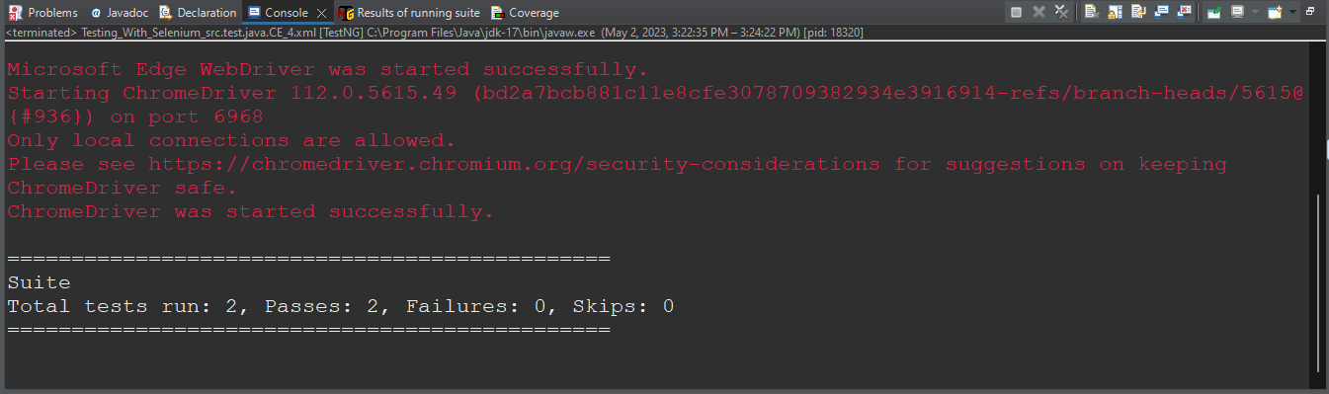

TASK- 05

package Test_Day5;

import org.testng.annotations.Test;

import io.github.bonigarcia.wdm.WebDriverManager;

import org.testng.annotations.BeforeMethod;

import org.testng.annotations.Listeners;

import org.openqa.selenium.By;

import org.openqa.selenium.WebDriver;

import org.openqa.selenium.chrome.ChromeDriver;

import org.openqa.selenium.chrome.ChromeOptions;

import org.testng.Assert;

import org.testng.annotations.AfterMethod;

@Listeners(Test_Listener.class)

public class CE_5_Day_6 {

WebDriver driver;

@Test

public void login() throws Exception {

Thread.sleep(4000);

driver.findElement(

By.xpath("//*[@id=\"app\"]/div[1]/div/div[1]/div/div[2]/div[2]/form/div[1]/div/div[2]/input"))

.sendKeys("Suvitha");

driver.findElement(

By.xpath("//*[@id=\"app\"]/div[1]/div/div[1]/div/div[2]/div[2]/form/div[2]/div/div[2]/input"))

.sendKeys("12345");

Thread.sleep(4000);

driver.findElement(By.xpath("//*[@id=\"app\"]/div[1]/div/div[1]/div/div[2]/div[2]/form/div[3]/button"))

.submit();

Thread.sleep(4000);

String expected = driver.findElement(By.xpath("//*[@id=\"app\"]/div[1]/div[1]/header/div[1]/div[1]/span/h6")).getText();

Assert.assertEquals(expected, "Dashboard");

}

@BeforeMethod

public void beforeMethod() {

ChromeOptions co = new ChromeOptions();

WebDriverManager.chromedriver().setup();

driver = new ChromeDriver();

String url = "https://opensource-demo.orangehrmlive.com/web/index.php/auth/login";

driver.get(url);

}

@AfterMethod

public void afterMethod() {

driver.quit();

}

}

OUTPUT:

